Highcliffe School Student Bulletin

Monday 2nd – Friday 6th July 2007: Week B

Thought For The Week:
Don't criticize what you don't understand, son.
You never walked in that man's shoes.
Elvis Presley

YEAR 9: The 2008 Dutch Exchange is planned for next year. See Miss High for a letter, the postponed meeting will take place very soon so watch this space...

Activities Week: This year Activities Week runs from Monday 16th to Friday 20th July. As before, there will be opportunities for students to take part in many different activities. Letters outlining the main details will be sent home next week.
If you have be given letters already about specific trips/activities already, please make sure that you return the reply slips, payment etc as soon as possible.

Examples of activities taking place this year:
Year 7 | Take Your Child to Work Day; Emergency Services Safety Day; All Abroad trip to France; inter-tutor group activities; Splashdown trip
Year 8 | Hengistbury Head Outdoor Centre; Technology activities; International Day; The Real Game Careers Day; Science fieldwork at Hengistbury Head; Robotics; RC Cars; Puzzles Day
Year 9 | Health Education Day; Hengistbury Head Outdoor Centre; Salisbury trip; RAF Yeovilton trip; Technology activities; Creative Arts Day; Alternative Sports Day; Job Shadowing; RC Cars
Year 12 | Paintballing; Thorpe Park; day trip to France; Alternative Sports Day

MUSIC NOTICES:
The summer concert this week Thursday and Friday: Last few tickets on sale...

Rehearsals:

Guitar Club - Monday 3.30pm - 4.30pm

Harmonious Funk Jazz band - Tuesday 3.30pm – 5.00pm

Shout - Wednesday 3.30pm – 4.30pm (Years 7 - 9)

Vocalis - Thursday 3.30pm – 4.30pm (Years 10 - 13)

BRAINTEASER:

What is the mean age of Miss Richardson, Miss High and Miss White?

Answers to be submitted in the Brainteaser box in Ma6 before Friday 13th July.

Good Luck!

PE NOTICES:

The rescheduled date for Sports Day is Friday 13th July.
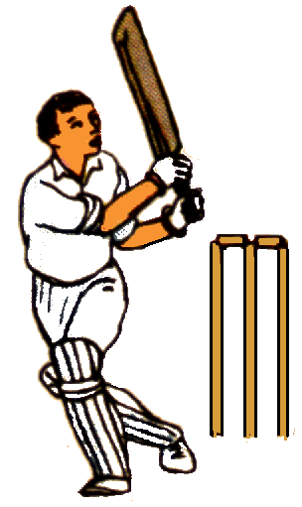
Results:
Year 9 rounders v Wentworth - lost
Year 8 rounders tournament - 2nd place overall
Year 10 cricket v BSB - won
Year 10 rounders v BSG - drew
Year 10 rounders v Corfe Hills - won

SUPER FACTS:

- Your tongue grows new taste buds about every two weeks
- Cold water weighs more that hot water...do you know why?
- As well as having four noses, slugs have a whopping 3,000 teeth to chomp through a load of lettuce

P.E. FIXTURES/PRACTICES

2nd July – 6th July 2007

 | LUNCHTIME | AFTER SCHOOL
Monday 2nd |  | Year 12 rounders v Poole High (A)
Tuesday 3rd | Year 10 cricket
Wednesday 4th | Year 7 cricket | Athletics club  Year 10 rounders v Grange (A)  Year 10 mixed rounders v Grange (A)
Thursday 5th | Year 8 cricket
Friday 6th | Year 9 cricket

